**Portal Team**

**Business Document**

**Introduction:**

Initially, we have planned to design the interface of the dashboard. In this application, the main screen will consist of two options one is for sign up for the new users and another one is for login for the existing users. When login screen in entered user have to give the user name and password credentials and click submit, then the credentials are validated. If the credentials are correct, then the screen will be directed to the user portal where he can find the applications. If the credentials are in-valid, then it will prompt them to enter the valid credentials. If the user is new to the organisation, then he must sign up first. When he enter the sign up page, he must enter the following details like Associate name, Email id, Associate Id, password. Once all the details are entered, then submit has to be clicked. Then, the registration successful is prompted and directed back to be main screen, where the user must login with the registered credentials to enter the portal.

After entering the portal, In header the user will find the user profile icon at the top right end with a drop down list for settings and log out. In the top left end, user can find the portal name with the logo. The dashboard will consist of the applications icon like chat box, QNA etc. In the right side of the dashboard, the user will see the reminders in the scrolling screen and events at the bottom. In the footer, user can find the helpline number and email and other contact details.

**Login-Screen:**

Process Purpose: This process is to ensure that the valid users are entering the portal.

Process Scope: In this process the user should provide the username and password which was created during the signup function and that details are checked to ensure that correct user are login into portal.

Process Input: The input of this process is username and password.

Process output: The output of this process is to allow the user to access all the applications in the portal.

**Signup-Screen:**

Process purpose: This process helps the user to create the account for accessing the portal.

Process Scope: In this process the user will enter the name, password, employeeid and email id for creating the account to access the web portal.

Process Input: Input of the process is name, password, employee id and email id will be entered by the user.

Process output: Output of the process is to make the user to create account in the portal which helps the user to access the portal.

**Dashboard-Screen:**

Process Purpose: This page will acts as a portal or connecting page to the various applications.

Process Scope: The page is developed to ensure that the user can find all the available apps in a single page. This page will act as the home page of the user. There will be a “My Profile” option where the user can enter and view all his personal information.

Process Input: The user can click the icons in order to access the various applications. The application which the user selected will be displayed. The user can also update his/her profile.

Process Output: If the user selects a particular icon, he/she will be directed to that application in the same pages. 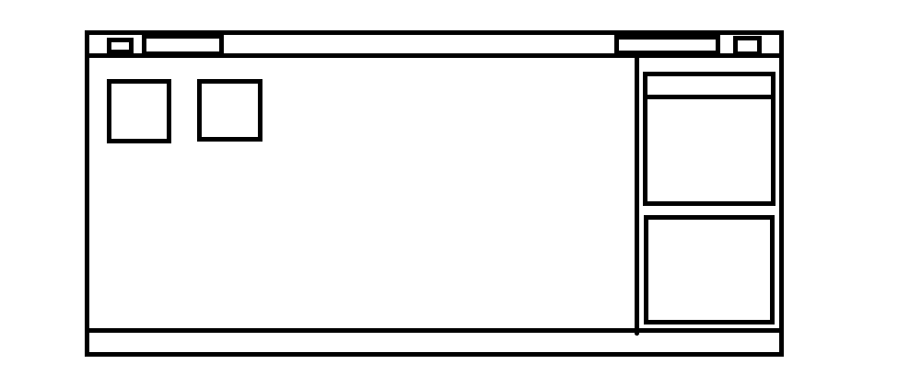

This is our wire-frame for the portal screen